TSUNAMI SOFTBALL 2025
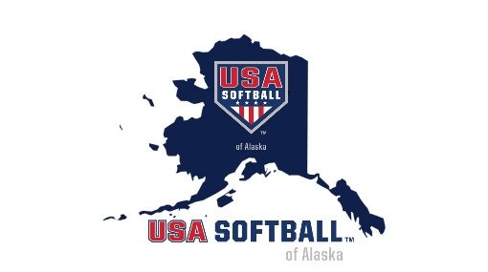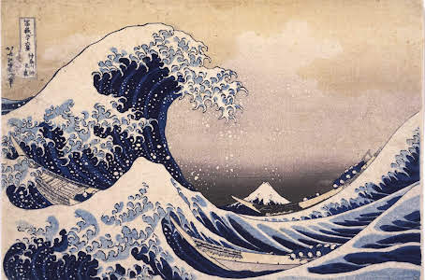
Early Registration is available!
Register for the Competitive Team or for the Recreational Team.
What’s the difference?

Competitive Team vs Recreational Team
Competitive teams
- Competitive teams are made up of players seeking competitive play that involves travel to Kenai and Anchorage, possibly Fairbanks. Players make the commitment to practice more intensively throughout the week and you are expected to participate in the Peninsula Tournament in Homer, the Birchwood Tournament in Chugiak. 18u/16u may possibly participate in the Tudor Bingo Tournament in Anchorage and 12u may participate in Alaska Futures in addition to the Peninsula Tournament and Birchwood Tournament. The head coach in conjunction with parents” will make the final decision on what tournaments their team goes to.

Fastpitch 2025 USA Softball of Alaska JO Statewide Calendar Red =planned attendance Green – possible attendance
DATE | DIVISION | TOURNAMENT NAME | CITY | FORMAT | FEE | DEADLINE | ASSOCIATION
May 24-25 | 10U 12U | Gregory Lee Memorial Tournament | Anchorage | RR/DE  4 game guarantee | TBD |  | Vipers
June 14  (Possibly Fri 13th) | 10U 12U 14U | Alaska Futures Tournament | Eagle River | TBD | TBD | “Green” | Arctic Heat
June 20-22 | 12U 14U 16U 18U  Possibly 10U | Tudor Bingo | Eagle River | 2RR/DE | TBD | “Green” | Arctic Heat
June 27-29 | 12U 18U | Peninsula Tournament | Homer | TBD | TBD | “Red” | Tsunami Softball
July 10-12 | 12U 14U 16U 18U | Birchwood Jamboree  (Home Run Competition  July 11) | Eagle River | 2RR/DE | TBD | “Red” | Arctic Heat
July 18-20 | 10U 12U 14U 16U 18U | JO State Tournament | Fairbanks | 2RR/DE | $450 |  | Interior Girls Softball Association

- The Early Registration Player Fee is $125 (Regularly $150) and we require a $100 check or cc # to be held until the end of the season when the uniform is returned and volunteer responsibilities are met. At that time those will be voided.
- In addition, you will be expected to cover housing and food when traveling and as a team split tournament fees.
- Lastly, if you wish to play on the competitive team you need to try out (we will then select 12-15 players per team). If you do not make a team you then will be offered the option to play on a Recreational Team.

Recreational Team
- Recreational Teams are made up of players who are wanting to learn the fundamental skills of softball and enjoy local competition in Homer and possibly Kenai. The first couple of weeks will be practice then it will be local games. If the coach and team desires to go up to a tournament that can be discussed with the Tsunami President.
- The Early Registration Player Fee is $125 (Regularly $150) and we require a $100 check or cc # to be held until the end of the season when the uniform is returned and volunteer responsibilities are met. At that time those will be voided.

Commonly asked questions:
What do travel/away tournaments look like? You are responsible for travel and housing but players often car pool and/or stay together. There is usually a gym available for a small donation. One meal is usually provided, possibly more.

What is the Player fee and Refundable uniform and volunteer fee?
$100 is given through a check or credit card agreement at the beginning of the season so the player can receive a full uniform (helmet, uniform, belt and socks). In order to get your $100 returned at the end of the season you must return your full uniform AND complete 100 “points” of volunteer time (we hand out a list of ways to earn the points by volunteering).

How do I get volunteer points?
A list of equivalents is available – coaching, umpiring, field work, snacks, etc

